**Design and Development of**

**VIDHAI**

**(Seed Sowing Machine )**

**Abstract**

Agriculture is the most important sector of the Indian economy. It is the most important source of employment for most of the workforce in the country. As the large workforce is employed in this area, traditional methods used in agriculture is time consuming and ineffective. A major issue faced by small scale farmers in recent times is sowing multiple crop seeds manually which is labor intensive and time consuming in their agriculture land. Cultivation is important inagriculture. Conventional Methods include hand ploughing withploughs and manually sowing the seeds in these grooves while modern methods include powered seed sowing with machines. The cultivation process involves multiple functions like ploughing, tilling the soil, creating the burrows, sowing the seeds and covering the burrows with the soil. This project is focused on designing an innovative mechanism to incorporate all these functions of cultivation into an efficient and cost-effective machine for small scale farmers. The main objectives of this device are to increase the efficiency with minimum labor and to reduce its cost. The uniqueness of this machine involves its multi-functional character and can be used for multiple crops with varying requirements. The machine involves a slider crank system to create the burrow of different depths using telescopic links which is powered by the wheel axle using chain drive. A valve is used to regulate the flow of seeds into the burrow at the spacing required for each crop. A gear system has been incorporated to adjust the spacing between the seeds for different crops. The valve is also powered by chain drive from the wheels. A mud closer has been attached at the rear end of the machine to close the burrow of the seeds while a roller with swirled blades has been attached in the front end to till the soil. The machine can be maneuvered by the farmer using the handle. The complete CAD design of the model has been designed in Solid Works 2017 and the analysis for the same has been done in Ansys 18

The **Keywords:** Seed-sower, Design, Cost minimization, CAD model.   
  
**Content:**

**Introduction**

**Objective**

The focus of this project is to design and develop a machine to sow seeds mechanically. The seed sowing system was designed to incorporate and accomplish all the tasks involved in cultivation which involves tilling the soil, digging the burrow for the seed for sowing an array of seeds of variable quantity at definite intervals of space and to close the borrows with residual soil. This device was developed to assist the small-scale farmers in the fields. It has been designed to be highly flexible as to be used for multiple crops. Hence a gear system is used to change the seed spacing and a telescopic link to vary the depth of the burrow. The machine can be controlled manually or can be dragged by cattle. This mechanism increases the cultivation efficiency for a given mechanical effort at a very reasonable cost.

**Existing Models**

There are various existing models for seed sowers in the market. The models range from miniaturized models used for small agriculture lands to heavy powered machines to sow rows of seeds simultaneously in large farmlands. But there are certain shortcomings in the current models.

* The small models can only be employed in small farmlands and can only sow seeds.
* Tilling, burrowing the land and closing the burrow must be manually done by the farmer.
* The existing models are not flexible and can only be used for a single type of crop.
* The depth of the burrows and spacing between seeds is unalterable.
* Heavy machinery cannot be used for small scale farmlands and are expensive.

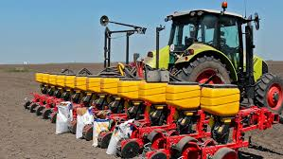 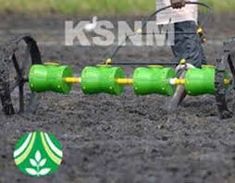 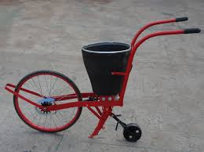

**Literature Survey**

**Vidhai**

The machine consists of mainly two mechanisms, the first consists of a slider crank mechanism and the second being a rotating valve mechanism. The device a purely mechanical device which is powered by the wheel axle. The crank of the slider crank mechanism is attached with a 6-gear system which is in turn powered by the wheel axle using chain drive. The gear system is used to alter the crank speed for a fixed speed of the wheel using different gear ratios. Different crank speed is responsible for the spacing between successive seeds that are sown. The slider is mounted with a conical tip to dig the burrow in a cyclic fashion to create the burrow to sow the seeds. The slider is made using telescopic links to increase the depth the of the burrow based on the crop requirements. This system replaces the dragging setup with a cyclic digging setup to decrease the resistive load offered by the land

The rotatory valve mechanism consists of a cylindrical portion with a depression on its surface. This part is attached to a shaft that is powered by the crank shaft using chain drive. The cylindrical part rest exactly beneath the seeds inside the hopper. Hence as the shaft rotated, a fixed number of seeds that can be accommodated in the depression will fall out in a guide vane and will be guided perfectly to the depression created by the slider crank. To vary the number of seeds falling, the valve must be explicitly changed manually.

A mud closer and a roller with swirled blades has been attached in the rear end and front end respectively to till the soil and to close the burrows after sowing the seeds.

The product will have a frame wherein the entire setup, including the slider crank, roller blade, rotating valve and mud closer will be placed to make it more compact and ergonomically efficient. A handle bar is attached to the frame to facilitate maneuvering of the device.

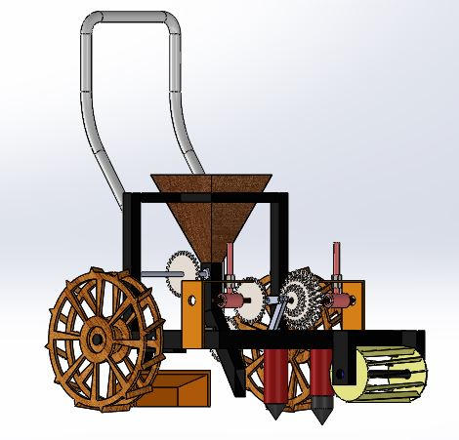

**Design of the Seed Sower**

**Assembly of the Seed Sower consists of**

* Hopper with valve mechanism
* Mud closer
* Rolling swirled blade tiller
* Telescopic slider crank
* Handle bar
* chassis

**Design of the hopper and rotating valve**

A hopper consisting of a guide vane is designed to regulate the seed flow. The seeds are stored in the hopper in bulk amounts. The guide vane is a tube of a square cross section. A small funnel is placed inside the cross section below which rests the rotating valve. The valve acts as the stopper for the seeds from falling. The valve is a cylindrical part with a small depression on it which accommodates a fixed number of seeds and this is attached to a shaft which in turn is attached to a bearing. Whenever the valve undergoes a cyclic rotation, the seeds fall down the guide vane due to gravity to the exact position of the burrow created by the slider crank. This has been predetermined using the velocity of the machine and has been designed accordingly. The valve shaft is run by the crank shaft using chain drive and hence the regulation of the seeds sown are controlled by the speed of the crank.

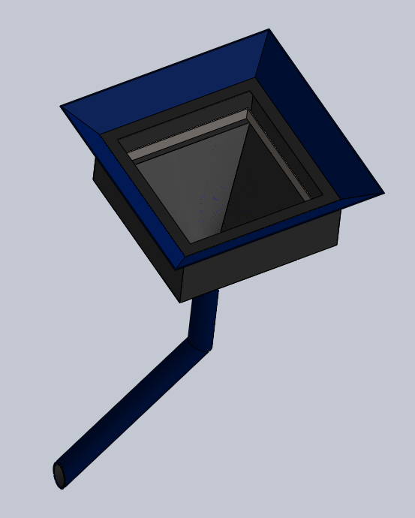 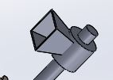

**Design of slider crank mechanism**

The slider crank mechanism is responsible for digging the burrow for sowing the seeds. The crank of the mechanism is attached with a 6-geared system with a shaft which is powered by the axle of the wheels using chain drive. The slider of the mechanism is responsible for the digging of the burrow and hence the slider is equipped with a conical tip to dig the burrow. The slider will penetrate the depth at cyclic intervals and the spacing between successive depths is governed by the gear system ratio that has been deployed. A derailed system has been attached to adjust the tension in the chain for the gear system. The slider is equipped with telescopic links to manually adjust the depth of the burrow which varies from crop to crop. This feature decreases the resistive load of dragging component to create the burrow in the existing models

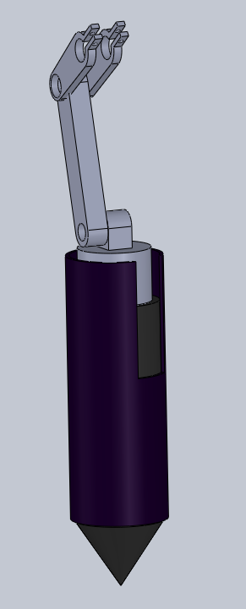

**Design of handle**

The handle is designed ergonomically to push the machine to remove weeds. The handles are provided at a height of 1m from the ground for the user to provide pushing angle of 20 degrees of 600N. The handle has been designed using carbon-fiber for this purpose.

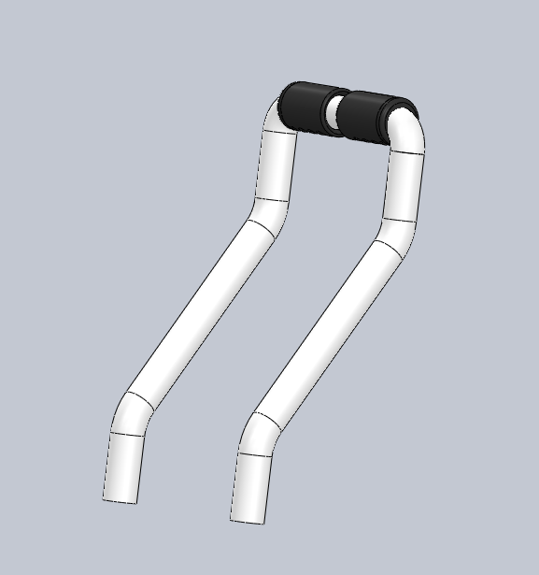

**Design of the chassis**

The platform has been designed to carry the load of the hopper, valve mechanism, slider crank mechanism, mud closer and the swirled blade roller. The platform has been designed using mild steel to handle stress. It is used for structural properties and is also light weight. The material cost drastically reduces due to availability and easy machinability.

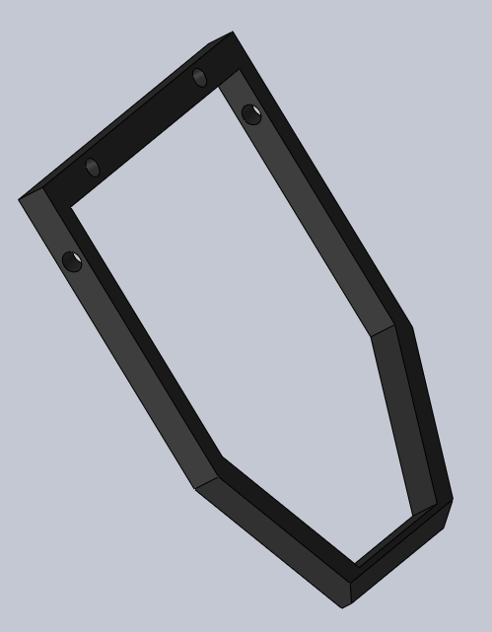

**Design of the swirled blade roller**

The swirled blade roller has been attached to the front end of the machine to till the soil of the cultivation land. The hard soil of the farmland cannot be directly used for sowing seeds. The soil must be loosened by tilling the soil which involves uprooting the small plants at the root level and in turn results in loosening the soil. This process is generally done as a separate cultivating practice by the farmers. Vidhai tries to incorporate this function in its design using the swirled blade roller. Th blades of this roller has been specifically designed to solve this issue of tilling the soil and hence, as the machine is pushed forward, the roller tends to rotate and in turn tils and loosens the soil for digging the burrow and sowing the seeds.

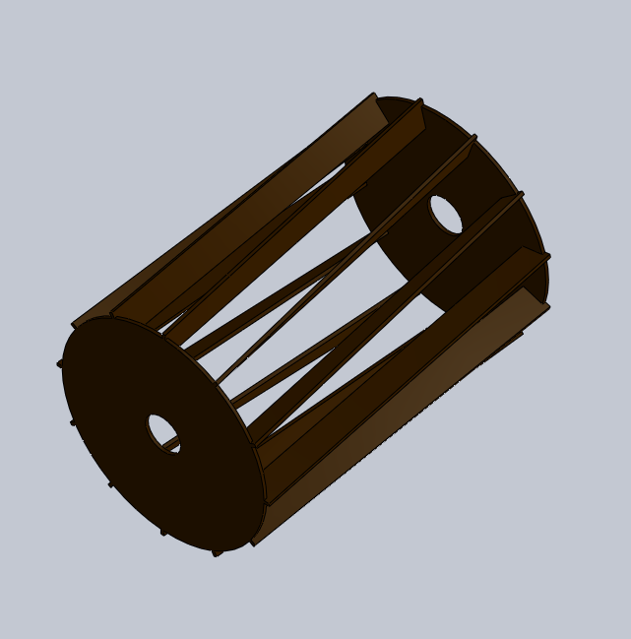

**Design of the mud closer**

A static mud closer is designed and is attached to the rear end of the machine. The function of the mud closer is to cover the burrow with seeds that have been sown completely using the residual mud that lies around the burrow by dragging the soil along with it.

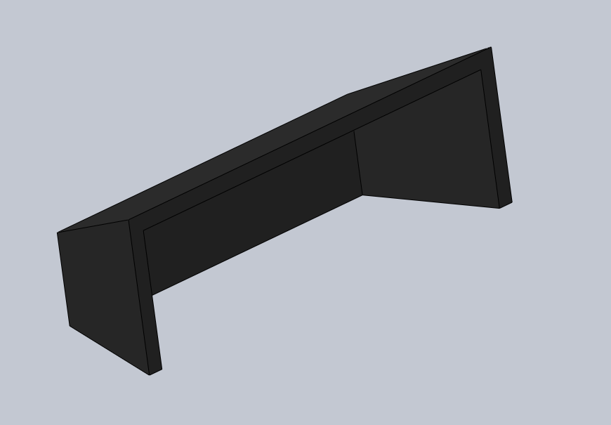

**BODY DIMENSIONS SLIDER-CRANK DIMENSIONS**

* Length – 90cm Crank – 3cm
* Breadth – 46cm Coupler – 13cm
* Height – 75cm Slider – 15cm
* Wheel diameter – 32cm weed roller length – 18cm
* Hopper section – 18*18cm2 weed roller radius – 18cm

**Innovation in Vidhai**

**MECHANISM USED FOR SEED METERING:**

The seed metering is controlled by a rotary valve mechanism. A hopper consisting of a guide vane is designed to regulate the seed flow. The seeds are stored in the hopper in bulk amounts. The guide vane is a tube of a square cross section. A small funnel is placed inside the cross section below which rests the rotating valve. The valve acts as the stopper for the seeds from falling. The valve is a cylindrical part with a small depression on it which accommodates a fixed number of seeds and this is attached to a shaft which in turn is attached to a bearing. Whenever the valve undergoes a cyclic rotation, the seeds fall down the guide vane due to gravity to the exact position of the burrow created by the slider crank. This has been predetermined using the velocity of the machine and has been designed accordingly. The valve shaft is run by the crank shaft using chain drive and hence the regulation of the seeds sown are controlled by the speed of the crank.

.

**MECHANISM USED FOR DIGGING**:

For digging the machine uses a slider crank mechanism. This basically contains a crank, a connecting rod, a slider and a guide. The rotary input is given to the crank which is transmitted to the slider through the connecting rod making it to undergo an oscillatory motion. In order for the crank to rotate fully the condition L> R+E must be satisfied where R is the crank length, L is the length of the connecting crank and slider and E is the offset of the slider. The crank is powered by the wheels which in turn reciprocates the slider. A gear system is used between the input and output to the digging mechanism. When a gear is engaged, the distance between two voids will remain constant irrespective of the wheel speed. The offset of the slider with a conical end is used to penetrate and dig the soil, whenever it reaches its extreme position, by 5 cm, in every cycle of the crank. The slider also rotates about its axis to make it more effective in any soil conditions. The rotation of slider is powered by a motor.

**Why is this model more efficient than existing models**

1. **Mode of Operation**:

It is a purely mechanical machine where the farmers only have to provide the forward push and its direction. Since it is multidirectional they can move it in any direction as per their convenience. The multi directional feature is facilitated by spherical wheels with pegs to provide traction and hence reduces human effort

1. **Cost**:

The cost of our model has been drastically reduced by optimizing its design and material. It varies from 3k to 7k based on its versions. This is one of the cheapest multi-functional cultivation machine that is purely mechanically run with such efficiency and coverage area in the market.

1. **Efficiency**:

The main reason for efficiency decrease in case of seed sowers is because of friction between the machine and soil. Our machine been designed to reduce this friction while being able to move around in all directions easily. The slider crank digging tool drastically decreases the resistive load and hence increases the work output for an input and hence increases efficiency.

1. **Versatility**:

This unique design permits the device to be used for multiple crops with various specifications. The depth of the burrow can be altered accordingly and the spacing between successive seeds sown can be altered. Even the number of seeds to be regulated can be varied by changing the valve manually

**Multi-functionality**:

Owing to the uniqueness of the design of the machine, the device can be used for multiple agricultural practices ranging from weed removal, soil tilling, ploughing burrows, seed sowing and covering the burrows with soil. All these functions can be performed by this single device and all these functionalities have been synchronized perfectly to provide the respective output.

**Compactness**:

Farmers need a very compact and small machine that can sow seeds. Our design consists of only mechanical parts. Our entire device weighs 13kg, and requires very little manual effort. The only effort that has to be invested upon is the handling of the device. The device spans an area of

**Analysis**

The entire model has been analyzed using Ansys 18.1.the stress distribution on various plates and nodes have been calculated while considering the material that is to be used. The materials have been chosen to optimize the weight and cost of the machine.

The stress distribution on the platform has been calculated for the weight placed on it including the valve mechanism and the slider crank mechanism with the conical tip for digging the burrow.

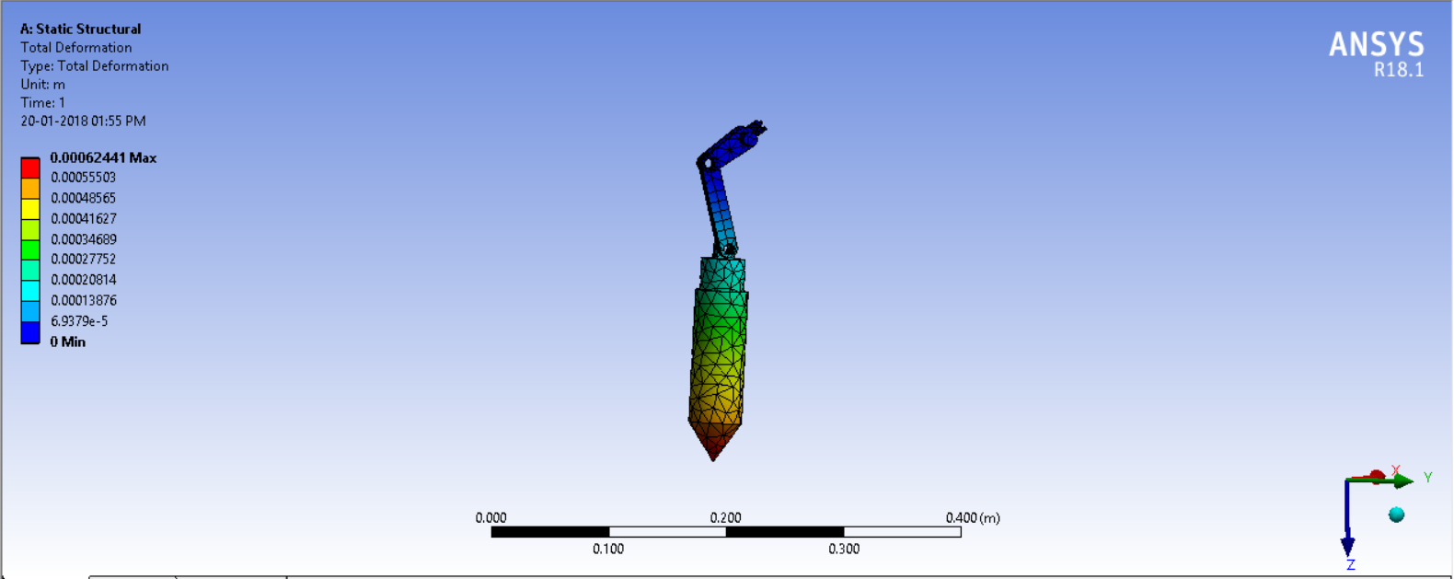 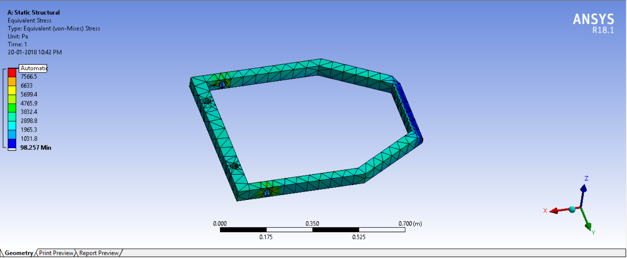

The stress analysis on the handle bar and the soil tiller has also been analyzed

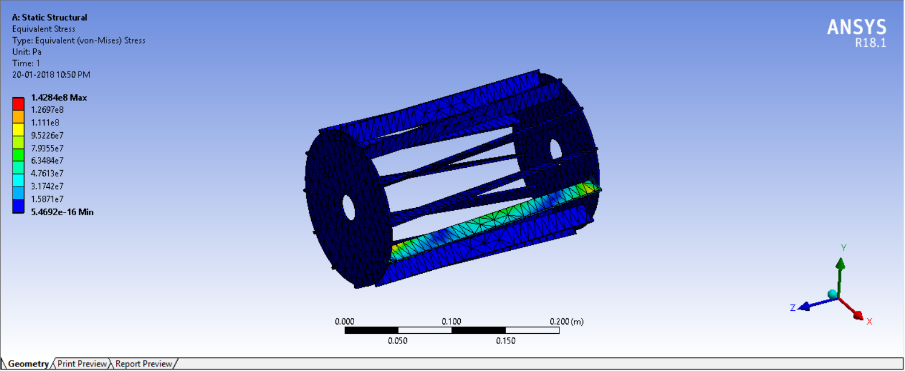 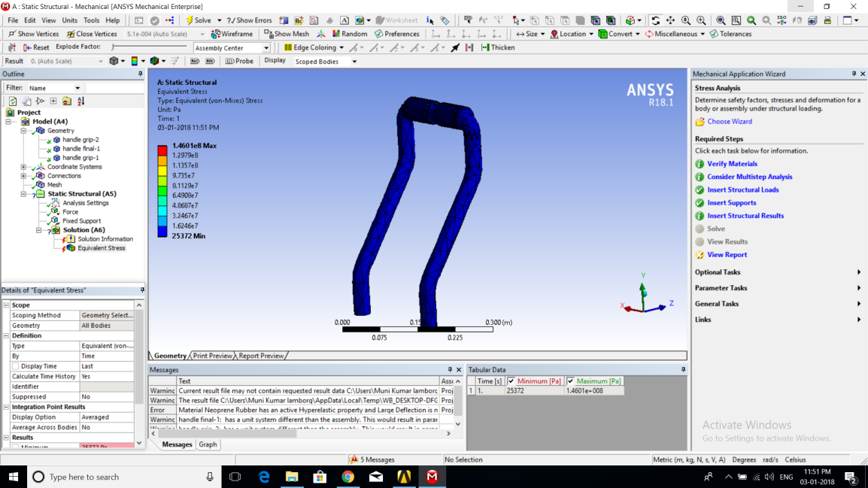

**Cost and material analysis**

|  |  |  |
| --- | --- | --- |
| **Materials** | **Specifications** | **Expenditure (in Rs)** |
| Tubes and Solid Members   * Square Tubes * Circular Tubes * Circular Solid Shaft | 2x2cm – 1.8m  2.5x2.5cm - 3m  3x3cm - 0.3m  4x4cm – 0.5m  1.5inch dia-1m  12mm dia-1.5m  16mm dia- 0.5m  32mm dia – 0.6m | 150 (40/kg)  180 (40/kg)  225(40/kg)  275(40/kg)  90 (45/kg)  250(44/kg)  300(44/kg)  550(44/kg) |
| Other metallic Components   * Mild Steel Plates | 2x2ft | 400 (35/kg) |
| Other elements   * Wheels * Ball Bearings * Bicycle Bearings * Bolts and Nuts * Plywood | 2 * 175/piece  2 * 40/piece  2 * 50/piece  2 * 2 ft | 350  80  50  210  300 |
| Manufacturing and Other Costs |  | 1500 |
| Total Cost of Machine |  | 4500/unit |

**Formulas and Calculations**

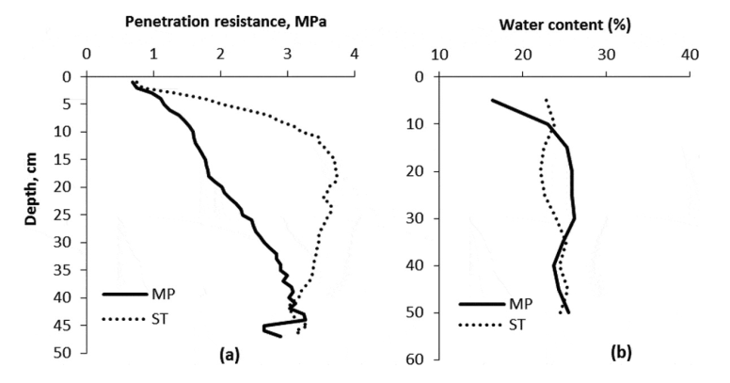



Radius of the Wheel = 0.14 m

Velocity at which the machine moves = 0.3 m/s

Radius of Wheel * Angular Velocity of wheel = Velocity of wheel

Fixing the Gear Ratio = 2:1 for wheels and valve,

According to this gear ratio, for every 1.465 the seeds will fall through the guide vane.

The inter seeding distance =

= 0.3 * 1.465

**= 0.4395 m**

Similarly, by proceeding the same calculation steps for different gear ratios, we have tabulated the values.

**GEAR TRANSMISSION TABLE**

|  |  |  |  |  |  |
| --- | --- | --- | --- | --- | --- |
| **Gear Ratios** | **Speed of Vehicle (m/s)** | **Distance between vane and slider(m)** | **Angular Velocity of wheels** | **Angular velocity of Piercer** | **Inter seeding Distance (m)** |
| 2.25:1 | 0.3 | 0.1 | 2.14 | 4.82 | 0.22 |
| 2:1 | 0.3 | 0.1 | 2.14 | 4.28 | 0.25 |
| 1.75:1 | 0.3 | 0.1 | 2.14 | 3.74 | 0.285 |
| 1.5:1 | 0.3 | 0.1 | 2.14 | 3.31 | 0.375 |
| 1.25:1 | 0.3 | 0.1 | 2.14 | 2.675 | 0.4 |
| 1:1 | 0.3 | 0.1 | 2.14 | 2.14 | 0.5 |

**Penetration Resistance offered by soil:**

R – Penetration Resistance

a – Acceleration of slider

h – Height of drop = 0.05 m

A – Area of cross-section of slider

– Depth of cavity = 0.05 m

M – mass of slider

m – mass of shaft = 0.5 kg

From the research papers, for agricultural land

R = 450 kgf/m2

= 450 * 9.8 = 4410 N/m2

Diameter of the cone = 0.045 m

Area of cross-section of slider = r2 = 0.0.0452/4 = 0.0015 m2

The slider undergoes a SHM

a = -

a = v * (dv/dx)

v * (dv/dx) = -2 * x

v2 = 0.394

v = 0.627 m/s

Average Acceleration =

x2 - 1.31x – 0.66 = 0

**x = 1.7 Kg**

**Mass of Slider = 1.7 Kg**

**Future scope for improvement**

The model can further be modified in the following ways:

1. Fertilizer provision can be attached to add fertilizer during cultivation.
2. Individual parts can be made removable for maintenance purpose
3. The shape can be altered to be more compact.

**Conclusion**

The designed model proves to be an effective and cost-efficient alternative to the existing equipment’s available. This model is aimed at helping low scale farmers who cannot afford to purchase these expensive machines. VIDHAI finds extensive use in agriculture, especially in horticulture, where the spacing between the seeds is very important. This helps to reduce the wastage of seeds. A variety of seeds of any size and shape can be sown with the help of this machine. VIDHAI is a farmer friendly device as it is ergonomically designed with simple mechanical parts. This requires low maintenance for the device and also does not require the farmer to require any pre-requisite knowledge to use the device making VIDHAI a versatile, eco-friendly and cost-efficient seed sower.